

Designing a program

Assignment 1



Unit 12

Helena vemba

1202227

Table of Contents

Introduction 2

Program 1 2

Purpose of the program and why you chose it 2

Calculator 2

Characteristics 2

Tools and techniques 3

Program 2 3

Purpose of the program and why you chose it 3

Characteristics 3

Tools and techniques 3

Review of both programs 3

Flowchart of both programs 4

Strength and weaknesses of both 6

Bibliography 6

# Introduction

This assignment is aimed to explain/understand the characteristics, including constructs and techniques being used within the program such as variables, constants and functions I also will identify uses of a Software Program of two different programs which are designed for different purposes, review the quality of both programs, e.g. efficiency/performance, maintainability and usability. This assignment I also will gain knowledge about it which may be useful in the future tasks.

# Program 1

[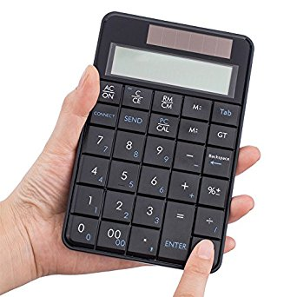](https://www.google.co.uk/url?sa=i&rct=j&q=&esrc=s&source=images&cd=&cad=rja&uact=8&ved=2ahUKEwjj_efR4LzaAhXK1RQKHUpfAEgQjRx6BAgAEAU&url=https://www.amazon.com/Focus-Wireless-Calculator-Financial-Accounting/dp/B01N1Q2BP0&psig=AOvVaw3tiUFvqHyTZa7HQyDwCmAA&ust=1523898000929906)

## Purpose of the program and why you chose it

## Calculator

The purpose of the calculator is used to make accurate mathematical calculations/operations, in addition (+) subtraction (-) multiplication (×) division (÷) after you use this it will be displayed result, calculator will contain 1 to 9 digits. Take this as example:

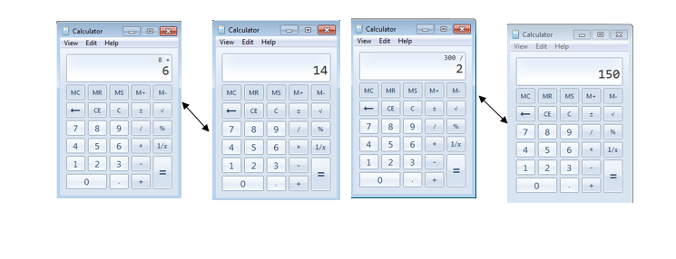If you add 8+6 the calculator will automatically display the result which is 14, the same happens to any other operation

## Characteristics ,tools and techniques

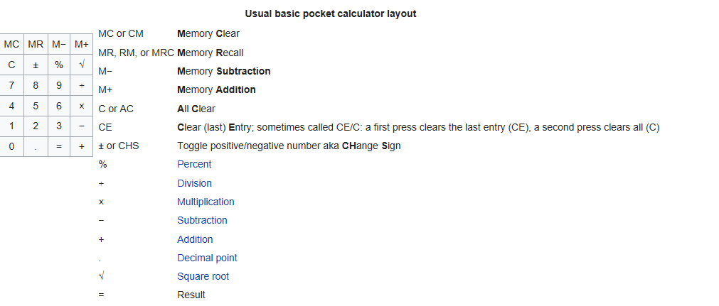The programming language is visual basic, the characteristics that calculator contains is basic string textbox a bold title is displayed because of the calculation, text, and various buttons containing numbers and other type of characters, a grey background. Must of the calculator have help button, same un-colourful background and no images displayed... The techniques used for Text Box and Buttons

This should include the constructs and techniques used in the program. What you believe the variables of the program will be. If it is a calculator, will it have variables? Constants? Functions?

# Program 2



## Purpose of the program and why you chose it

## Currency converter

Currency converter is a process of exchange rate (money) from other countries by estimating the value, a [person](http://www.investorwords.com/14646/person.html) can receive [less](http://www.investorwords.com/10174/less.html) or more [value](http://www.investorwords.com/5209/value.html) after the currency is converted just depends on the rate of the currency.

# The characteristics, tools and techniques of currency converter

The tools used from the tool box are Buttons and text Box, it contains a bold title, text, textboxes and two buttons, normally the background are a grey or white and doesn’t contain a colourful background or an image so this program is considered non- graphical program. The codes used in the program doesn’t contain the conditional IF statement, do and repeat, the programming language that is used is visual basic that shows the conversion between the currencies. The techniques used are basic string handling, dragging and selecting options of text box and button is placed where the user like to insert the Text Boxes and the Buttons.

Take the images below as example of currency converter:

## C:\Users\Miss\AppData\Local\Microsoft\Windows\INetCache\Content.Word\screenshot-1.jpg

# Review of both programs

Calculator

The quality of a calculator is very effective because people used to do mathematical operations by counting fingers, drawing dashes or doing by head but nowadays having a calculator saves time and give us instant result.

Currency converter

The program works very fast and well, the input and output are calculated very fast it has excellent efficiency, the maintenance of it is no one can’t see any comments or notes in the coding also there is no possible error that user can see that would make the program not do what is meant to do. In contrast doesn’t gives us the details how does it works only shows where you must enter the number and those sorts of things. Doesn’t freeze or crashes if you enter in incorrect data or too many figures, in case of a crash or freeze replaces with a pop up, notifying what the problem is and gives you couple of options such as continue or quit. Allowing the user to decide what they wish to continue using the program from where they left or exit the program. In my opinion currency converter should contain images.

## Flowchart of both programs

Currency Converter :

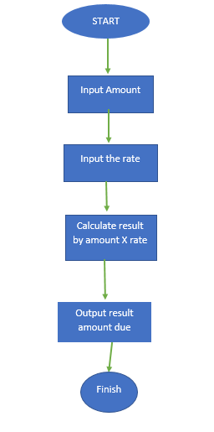Calculator:

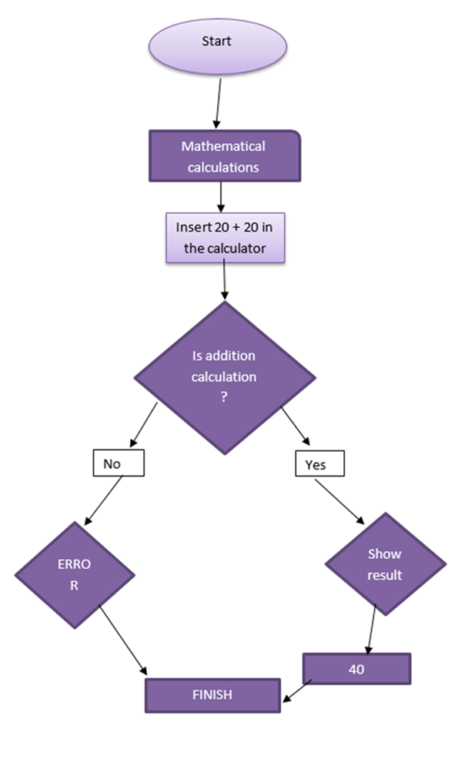

# 

# Strength and weaknesses of both programs

Some strength and weaknesses of both programs are similar such as daily use, both aren’t colourful both normally have grey background is displayed everyone I able to see it without any issues also both program is helpful in a way of knowing a giving the answer either for rate or mathematical calculations those programs fit for different kind of purposes such as businesses, educational, bank ... The currency converter is helpful and simple process it converts the answer of your exchange rate, software only let multiply up to 14 figures in each text boxes which are enter amount and enter rate. In contrast the program can’t have more than 16 figures in each of the two boxes. If you insert data in the incorrect text boxes a popup, inform the user of the issue that has happened and will which leave the user options that will be helpful for the user, will not be overwhelming. Users can easily access to setup of the program. There is different types of Assembly and Win32 versions, which are different types of CodeBase files, diverse types of systems the program can run and the various elements that created the program and details concerning to debugging.

In the currency converter doesn’t exactly tells you what type of exchange rate converter it is. One benefit that both programs could have a colourful program that possible attract the intended audience and the user will be more involved with the program. In my opinion the main weakness of both program is having no picture in currency converter should at least contain money images or flags to be easier and could be a way of making the user understand what is data to input or how to use the program.

The calculator is a helpful tool sometimes people cannot think fast and they need a quick response it will be easy to use, simple isn’t very difficult to understand, which could be especially useful people with reading problems although the text could be bigger to make it more clear, users will be able to access it many ways and on lots various devices, there is good layout ,organized, the symbols are easy to understand, the text and labels are spaced easier to seek for character/numbers, users cannot use inappropriate character like typing numbers instead of letters.

# Bibliography

Hope, C. (2017). *Routine and Subroutine*. Retrieved from Computer Hope: https://www.computerhope.com/jargon/r/routine.htm

Microsoft. (2015). *Call an Event*. Retrieved from Microsoft: https://docs.microsoft.com/en-us/dotnet/visual-basic/programming-guide/language-features/procedures/how-to-call-an-event-handler

Microsoft. (2015). *String Manipulation Summary*. Retrieved from Microsoft: https://docs.microsoft.com/en-us/dotnet/visual-basic/language-reference/keywords/string-manipulation-summary

Microsoft. (2016). *File Handling*. Retrieved from Microsoft: https://docs.microsoft.com/en-gb/cpp/c-runtime-library/file-handling

Microsoft. (2017). *Collections and Data Structures*. Retrieved from Microsoft: https://docs.microsoft.com/en-us/dotnet/standard/collections/